9/17 Meeting
Date: 9/17/25
Time: 11:00am-12:00pm CDT
Attendees: Juliette Reeder, Jack Hicks, Forrest Tuschhoff, Dr. Chuck Bunting, Dr. Pavithrakrishnan Radhakrishnan

Agenda:
- Review EZNEC Sims
  - Wire Log-Periodic
- Discuss baluns
  - https://vk6ysf.com/balun_choke_balun_hf_reisert.html
  - What to look for based on VK6YSF’s testing?
- E-field strength and area spec:
  - 40’ was the target to accommodate the largest devices we anticipate to test, so in practice, we would like to setup the horizontal antenna next to the largest device (or lay it over) and expose this large device under test to a uniform electric field.
  - A smaller antenna would require multiple antenna locations
  - For uniformity, a goal of +3dB is the goal because we want to reach the minimum target E-field… if we expose an item under test that is less than the minimum target, we have “under tested” and will have to readjust.
  - As far as 3D space, 40’ x 6’x 6’ is a good target
- Discuss Forrest’s log-periodic antenna testing plan
- SOP
  - Template
- Info for expo:
  - Group Photos – Please have teams submit a high resolution team photo with members identified. Make sure to have teams list team members on the form from left to right!
  - Project Descriptions - How will your team’s project benefit industry/society? Project abstracts will work for this too!
  - Project Sponsorship Logos - If you have an industry partner or sponsor for your senior design team’s project, we need their logo or name so that they can be properly recognized in the program.
  - Space Needs - What will the teams project space look like during the EXPO? What equipment will you need? Table, TV monitor, power?
  - Please complete by October 15
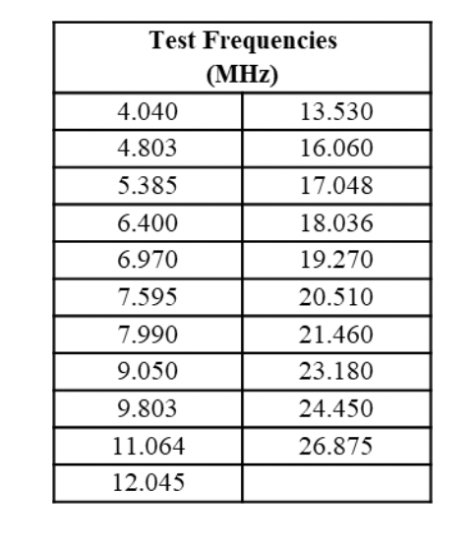

EZNEC Sims:
- Take a step back and do dipole
- Look at yagi models
- Figure out how to place sources -- look at posts (Reddit etc) for how to model this in software
- Look at log-periodic antenna datasheets to see where they are fed
- Check SWR as you go -- ensure it is close to 1
- Check S11 as you go
- Check currents

Balun:
- Look at PDF

Testing:
- Look at log-periodic
- Schedule time at richmond hills
- Tripod on the ground
- Spectrum analyzer and some kind of field probe
- S11 testing
- Trying to discern 3dB beamwidth
- Nano Spectrum Analyzer
- Drive with single source
- Step one:
  - Inside rotation test
- Step two:
  - Outside rotation test
- Step three:
  - Test moving in arc (move the field)
- Convert measurements to E-field to be able to compare with LUMILOOP

